**ASSIGNMENT 1**

SRIVIDHYA S

Roll No. 232030

Blogspot:<https://lensphotostudio2003.blogspot.com/2023/08/lens-photo-studio.html>

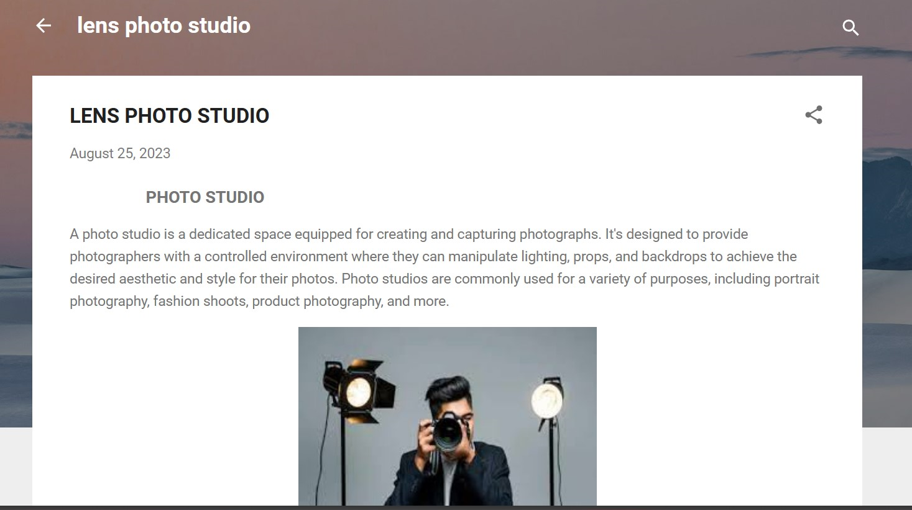

Wordpress:<https://srividh2003.wordpress.com/2023/10/21/lens-photo-studio/>

